

**Karachi School of Business & Leadership**

Department of Computer Science



“TopSHELF bookstore”

Applications of Information & Communication Technologies Lab (UID: FA2330) – Fall 2023



“PROJECT MADE BY Group - 02”

Umme Hani – B04–0923–000045

Maheen Fatima – B04-0923-000024

Submitted to **Sir Faisal Mehmood**

Submission date: 21/01/2024

Contents

Abstract 2

Introduction 2

Work : **Error! Bookmark not defined.**

Project Management 3

Project Manual 3

Project Results and Analysis 8

Challenges Faced 8

Conclusions 8

# Abstract

The "Top shelf Bookstore" project started as a goal to revamp Maheen's Wix-based college project’s website but on HTML, CSS and JavaScript. Initially uncertain, our dive into the project turned a simple task into a captivating challenge. Seeking help from friends, Google, and YouTube, we crafted a strategy: get inspiration from Wix’s template design while adding personal touches.

As first-semester students, we faced challenges, but our shared struggle led to improved coding skills. The experience instilled confidence and teamwork, transforming us into capable problem-solvers. In essence, the "Topshelf Bookstore" project reflects our growth, combining individual efforts and external resources to create a website with a unique stamp of our creative spirit.

# Introduction

In the vibrant landscape of online commerce, the fusion of literature and technology manifests in the creation of TopShelf BookStore, a digital haven for bibliophiles seeking an immersive and convenient book-buying experience. This web-based venture, meticulously crafted using HTML, CSS, and JavaScript, beckons readers into a virtual realm where the allure of captivating narratives meets the seamless navigation of a user-friendly interface.

### Problem Statement:

The project aimed to build a fully functional and aesthetically pleasing bookstore website using basic HTML, CSS, and JavaScript. Since some websites might be a bit difficult to navigate, the problem to be solved was to create something aesthetically pleasing but also easy to navigate. A bookstore website that could promise a good amount of purchasing. Specific goals included integrating features such as displaying bestselling and recommended books, showcasing new book launches, providing a 'Contact Us' page, presenting a comprehensive book collection, and designing a 'Book Purchase' page.

### Motivation:

Solving this problem was essential to create a user-friendly online bookstore. The goal was to offer an easy-to-navigate platform, catering to users' needs and providing a seamless experience for browsing and purchasing books.

### Past Work:

The project is now complete, overcoming the initial challenges faced during the learning phase. The struggles encountered as beginners did not hinder the overall success of the website.

### Challenges:

While there were initial struggles as new learners, the subsequent phases of the project proved successful, and the challenges were overcome. From knowing nothing to learning how to create a fully functional header, footer theme, and place content as per our wish, we ended up building a website in which we have poured all our heart and soul. We took help from countless YouTube videos and websites such as W3schools, etc. which cleared a lot of our concepts.

### Approach:

The development process involved a collaborative effort as a duo, learning, implementing and mainly focusing on CSS and JavaScript. The focus was on creating a website that not only met basic functionalities but also provided an enjoyable user experience.

### Main Results:

The completed project includes a fully functional website with features such as a homepage displaying bestselling books, the bookstore's recommendations and a new book launch section, an 'Our Books' page, and a 'Book Purchase' page with detailed book information, and a return and refund policy. The Website also includes a Contact Us page that is created to address and receive queries or requests for a book from the client shopping.

### Contributions:

The contributions to the project significantly enhanced understanding, especially as new learners. The collaborative effort as a duo proved instrumental in overcoming initial challenges.

### Report Organization:

The subsequent sections will delve into specific challenges faced during the initial learning phase, the strategies employed to overcome them, assumptions made during the development, detailed results achieved, and reflections on the overall contributions to the successful completion of the bookstore website.

# Work:

The "TopShelf Bookstore" project was initiated with a meticulous analysis of a Wix-based model, aiming to replicate essential features while injecting our creative flair using HTML, CSS, and JavaScript. Collaborative coding efforts were pivotal in achieving a delicate equilibrium between functionality, aesthetics, and user experience. Our primary objective was to deliver the services of the bookstore in the most pleasant way possible, with an emphasis on effective communication and seamless navigation. Initial outcomes included the establishment of the home page and the Contact Us page to address queries while building visuals.

# Project Management

As a team of two, we decided to divide tasks between each other. Maheen taking the leadership role and being more proficient with computer languages ended up making more efforts but upon equal enthusiasm, Umme Hani, as a diligent group member also tried to do as per her capacity and skills.

# Project Manual

Here some of the screenshots of how our website works:-

# Some screenshots of the index page

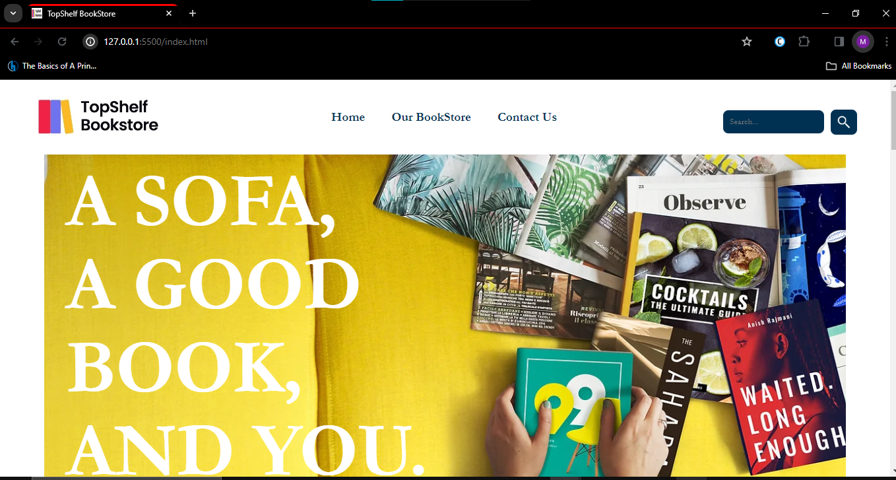 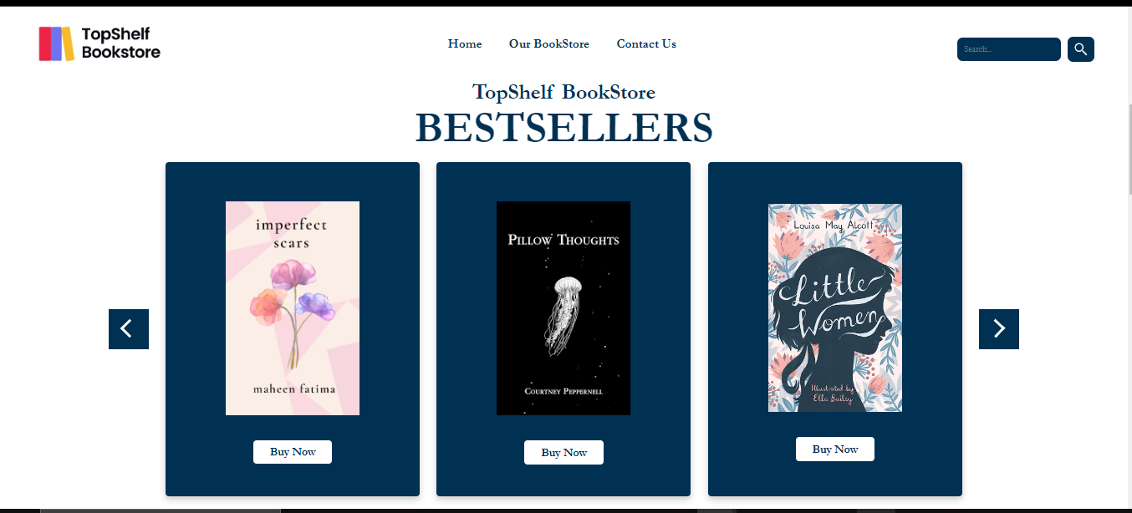

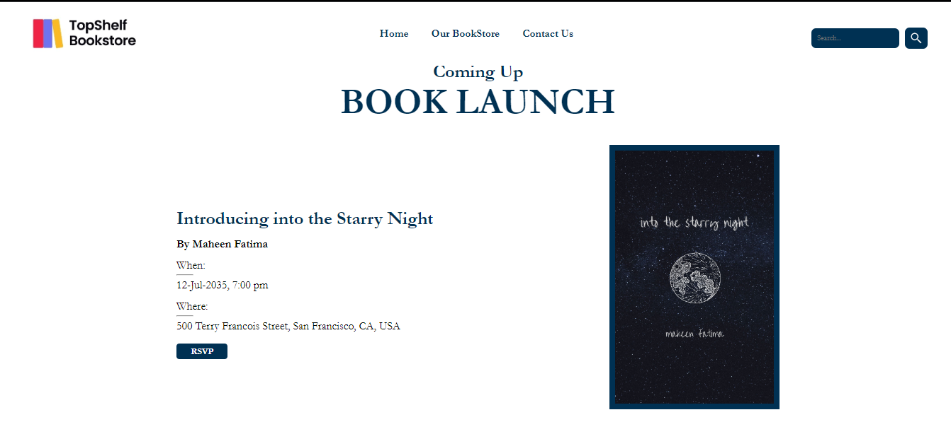



The webpage is designed to serve as the online presence for the bookstore and includes various sections to provide information and engage users. Here's a brief overview of the main components and purposes of the webpage:

1. **Header Section (in all pages):**
   * Displays the bookstore's logo.
   * Provides a navigation menu with links to "Home," "Our BookStore," and "Contact Us."
   * Includes a search bar for users to search for books.
2. **Hero Section:**
   * Features a visually appealing image and a title, creating a prominent introduction to the webpage.
3. **Bestsellers Section:**
   * Highlights a selection of bestselling books with images, a slider and links to purchase each book.
4. **Visit Section:**
   * Encourages users to explore more books with a call-to-action button linking to the "Our BookStore" section.
5. **Recommended Books Section:**
   * Presents a curated list of recommended books for the month, each accompanied by images and purchase links.
6. **Book Launch Section:**
   * Announces an upcoming book launch event with details such as the book's title, author, date, time, and location.
   * Includes an RSVP button for users interested in attending the book launch.
7. **Footer Section (in all pages):**
   * Provides contact information for the bookstore, including the address, phone number, and email.
   * Includes links related to shopping, such as FAQ, shipping & returns, store policy, and payment methods.
   * Features social media links (Facebook, Twitter, Instagram, Pinterest) for users to follow the bookstore.
   * Offers a newsletter subscription form for users to receive updates and promotions.

In summary, the webpage is designed to showcase and promote the TopShelf BookStore by featuring bestselling books, recommended books, and an upcoming book launch. Users can navigate through different sections, search for books, and engage with the bookstore through social media or newsletter subscriptions.

# Next we have the product purchase page:-

The specific purpose of this page is to showcase and provide detailed information about a particular book, which is "Little Women" by Louisa May Alcott. The page is designed to facilitate the user's interaction with the book, allowing them to learn more about it and providing options for purchasing. Here's a breakdown of the main component and purposes of the webpage:

1. **Main Content Section:**

This includes:

* Cover Image: The visual representation of the book's cover.
* Title: The name of the book.
* Price: The cost associated with purchasing the book.
* Brief Description: A concise summary or description of the book's storyline.
* Quantity Selection Dropdown: A dropdown menu allowing users to specify the quantity of the book they wish to purchase.
* There are two buttons provided to initiate the purchase process:

1. "Add to Cart": Clicking this button adds the selected book to the user's shopping cart, allowing them to continue browsing before finalizing the purchase.
2. "Buy Now": Clicking this button takes the user directly to the checkout process, bypassing the shopping cart and initiating an immediate purchase.

* Return and Refund Policy: Details on the bookstore's policy regarding returns and refunds.
* Shipping Details: Information about the shipping process, which may include delivery times, methods, and costs.

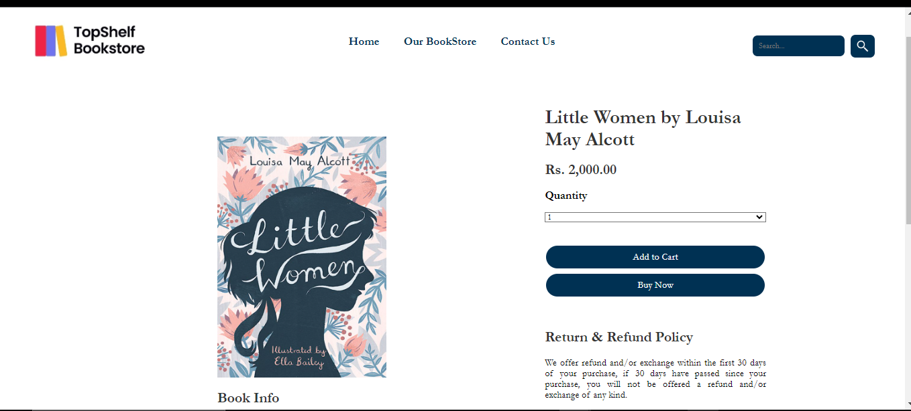

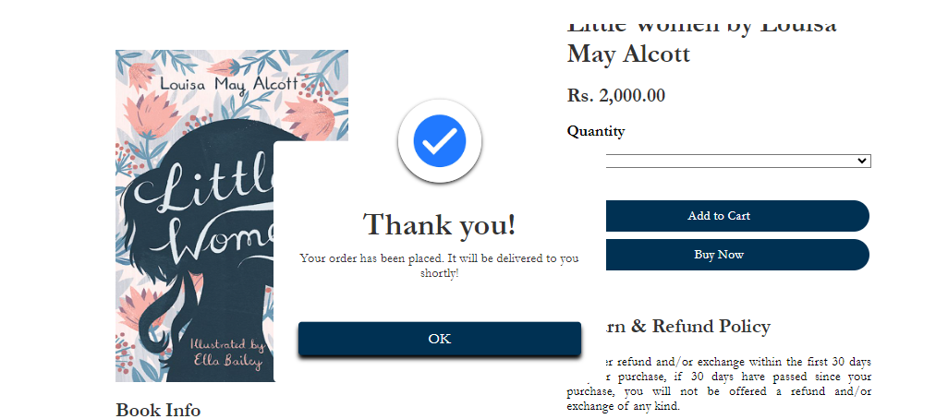

# About and Contact us page:-

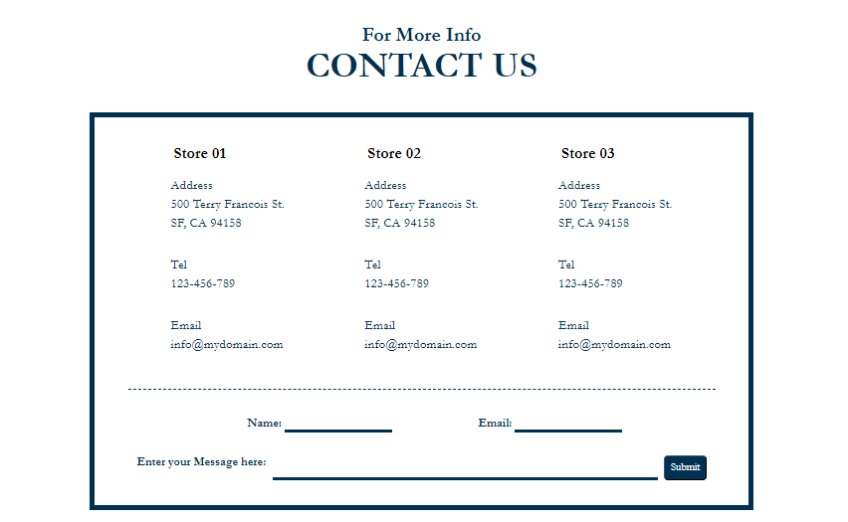

The webpage is created for the "Contact Us" section of the TopShelf Bookstore website. Its main purpose is to offer users a way to contact the bookstore through various store locations. The page includes:

1. **Main Content Section:**
   * Contact information for three store locations, including addresses, telephone numbers, and email addresses.
   * A form for users to input their name, email, and a message to contact the bookstore.

In essence, users can find details about store locations and reach out to the TopShelf Bookstore using the provided contact form. The webpage facilitates communication between the bookstore and its customers.

# Our Bookstore Page:-

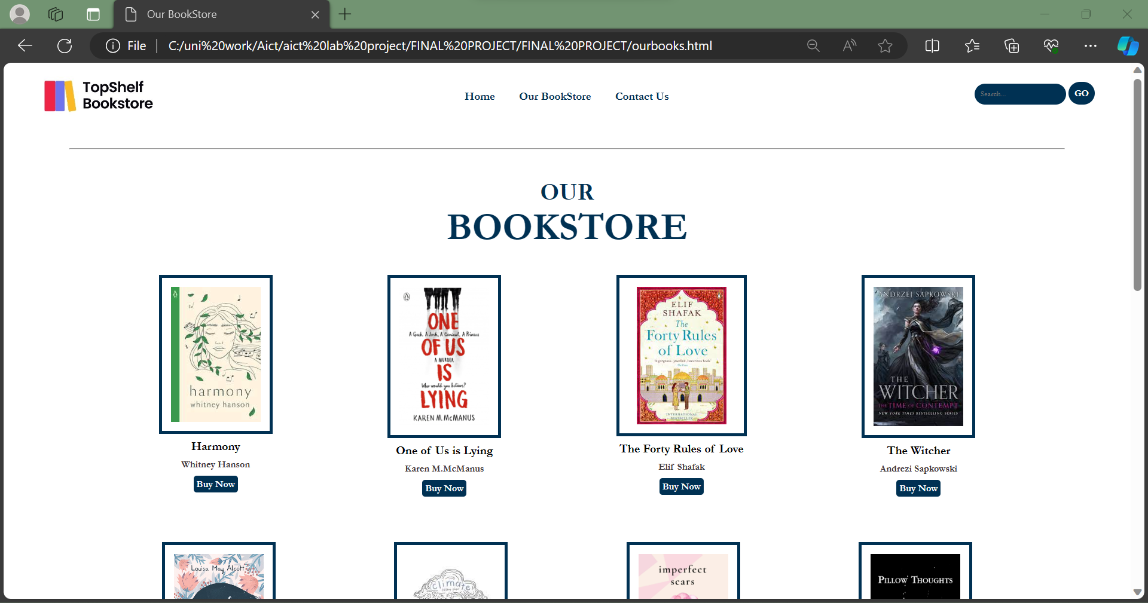 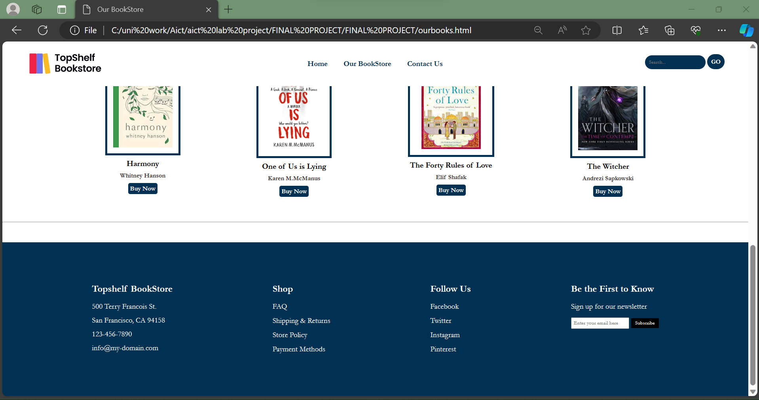

The webpage you provided is designed for an online bookstore. Its main purpose is to showcase a variety of books available for purchase. Here's a breakdown:

1. **Main Content Section:**
   * Features a grid layout displaying multiple books.
   * Each book entry includes an image, title, author name, and a "Buy Now" button.
   * Users can click the "Buy Now" button to potentially purchase the corresponding book.

In summary, the webpage is a digital storefront for an online bookstore, allowing users to browse through a selection of books and providing them with the means to make a purchase or stay informed about the bookstore through newsletters and social media.Top of Form

# Project Results and Analysis

**RESULTS:**

* **“**The 'Top shelf Bookstore' project yielded significant results as we successfully transformed a basic Wix-based college project into a visually appealing and personalized website. Through a meticulous process of mimicking Wix while infusing our individual creative touches, we achieved a successful revamp that surpassed our initial expectations and uncertainties**.”**

**Analysis:**

* **“**The 'Top shelf Bookstore' project results signify a successful transformation from a basic Wix-based project to a uniquely personalized website. This process honed our coding skills, showcasing adaptability and creative problem-solving. As first-year students, overcoming challenges strengthened our teamwork, fostering a collaborative spirit. Beyond technical gains, the project instilled confidence and facilitated personal growth. It made us realize that if given the efforts and dedication, it is possible by all means to achieve what you expect. The website stands as a testament to our creative spirit and collective journey, reflecting the integration of diverse skills into a cohesive outcome.**”**

# Challenges Faced

First, the problem was that we were facing a lot of issues with the alignments and page distribution but then when for a solution, we searched for some videos and information on how to fix and learn it, and then we implemented that on the code.

The second problem was with JavaScript, as we are not that much proficient in it so we faced some problems regarding that. Creating a logic for the image slider was indeed a difficult task but timeless devotion and a discussions with fellow peers made us find a way for it. The image slider works perfectly fine and displays the best-selling books on the homepage. We also incorporated a Thank You pop-up at the book purchase page as soon as the user clicks on buy now. Although integrating a cart, and retaining information could’ve been a difficult but an impressive task, we tried to do everything at our scope and reach to the best of our abilities so we just sticked to the Thank you message.

# Conclusions

The "TopShelf Bookstore" project has been a transformative journey for our first-year team, resulting in a visually appealing and personalized website. Despite initial uncertainties, we successfully revamped the Wix-based college project, showcasing improved coding skills and a creative problem-solving mindset. The website stands as a unique expression of our growth and teamwork, reflecting our journey from novice developers to capable problem-solvers. While challenges, such as alignment and JavaScript complexities, were encountered, proactive research and implementation solutions were sought. This project not only honed our technical skills but also deepened our understanding of HTML, CSS & JavaScript. The collaborative efforts and effective project management exemplify our cohesive growth as a team, ready to face future challenges in web development.Top of Form